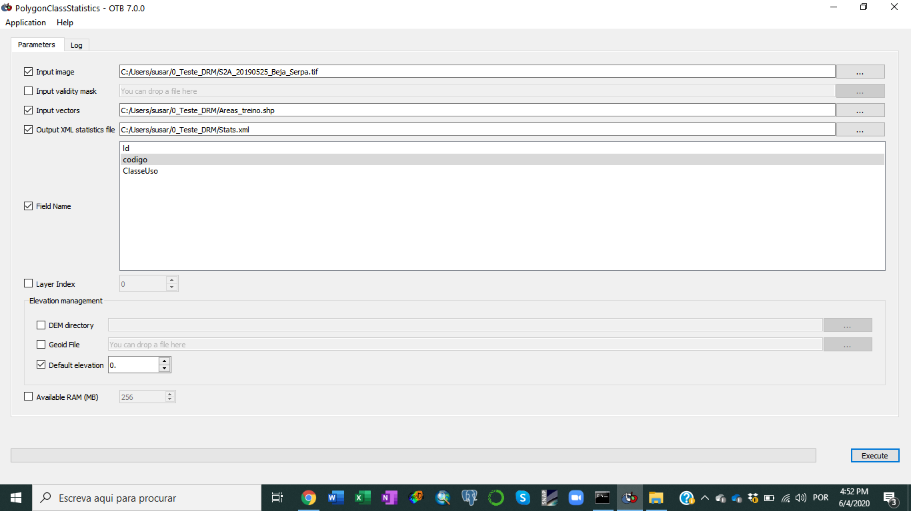
2020-06-04 13:47:52 (FATAL) PolygonClassStatistics: is a wrong extension for parameter "out": Expected .xml

2020-06-04 13:48:26 (FATAL) PolygonClassStatistics: is a wrong extension for parameter "out": Expected .xml

2020-06-04 13:48:33 (FATAL) PolygonClassStatistics: is a wrong extension for parameter "out": Expected .xml

2020-06-04 13:49:18 (FATAL) PolygonClassStatistics: is a wrong extension for parameter "out": Expected .xml

2020-06-04 13:49:22 (FATAL) PolygonClassStatistics: . is a wrong extension for parameter "out": Expected .xml

2020-06-04 13:49:28 (FATAL) PolygonClassStatistics: .x is a wrong extension for parameter "out": Expected .xml

2020-06-04 13:49:33 (FATAL) PolygonClassStatistics: .xm is a wrong extension for parameter "out": Expected .xml

2020-06-04 13:49:40 (INFO) PolygonClassStatistics: Default RAM limit for OTB is 256 MB

2020-06-04 13:49:40 (INFO) PolygonClassStatistics: GDAL maximum cache size is 403 MB

2020-06-04 13:49:40 (INFO) PolygonClassStatistics: OTB will use at most 4 threads

2020-06-04 13:49:40 (INFO) PolygonClassStatistics: Elevation management: setting default height above ellipsoid to 0 meters

2020-06-04 13:49:40 (INFO) PolygonClassStatistics: Execution took 0.267 sec

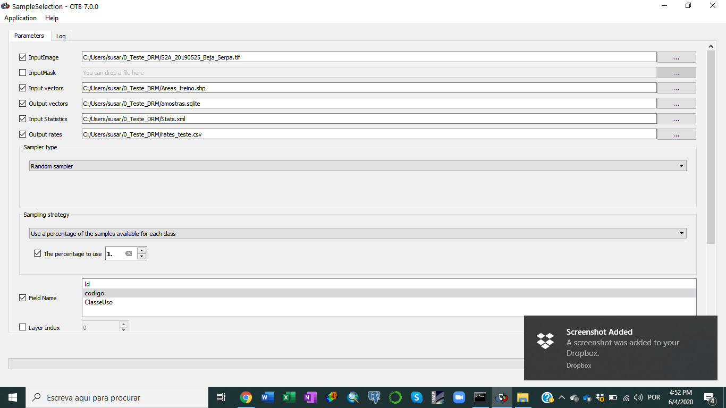
2020-06-04 13:51:54 (INFO) SampleSelection: Default RAM limit for OTB is 256 MB

2020-06-04 13:51:54 (INFO) SampleSelection: GDAL maximum cache size is 403 MB

2020-06-04 13:51:54 (INFO) SampleSelection: OTB will use at most 4 threads

2020-06-04 13:51:54 (INFO) SampleSelection: Elevation management: setting default height above ellipsoid to 0 meters

2020-06-04 13:51:54 (INFO) SampleSelection: Sampling strategy: set a percentage of samples for each class.

2020-06-04 13:51:54 (INFO) SampleSelection: Sampling rates : className requiredSamples totalSamples rate
100 13426 13426 1
200 2154 2154 1
300 9898 9898 1
301 1907 1907 1
400 5512 5512 1
401 3784 3784 1
500 2733 2733 1
600 1462 1462 1
700 8733 8733 1
800 2436 2436 1
900 6512 6512 1

2020-06-04 13:51:56 (INFO) SampleSelection: Execution took 1.17 sec

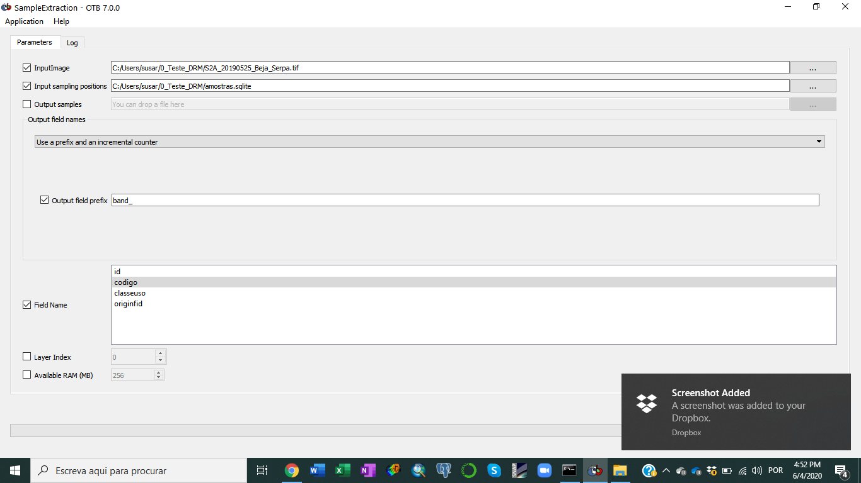
2020-06-04 13:52:48 (INFO) SampleExtraction: Default RAM limit for OTB is 256 MB

2020-06-04 13:52:48 (INFO) SampleExtraction: GDAL maximum cache size is 403 MB

2020-06-04 13:52:48 (INFO) SampleExtraction: OTB will use at most 4 threads

2020-06-04 13:53:04 (INFO) SampleExtraction: Execution took 15.512 sec

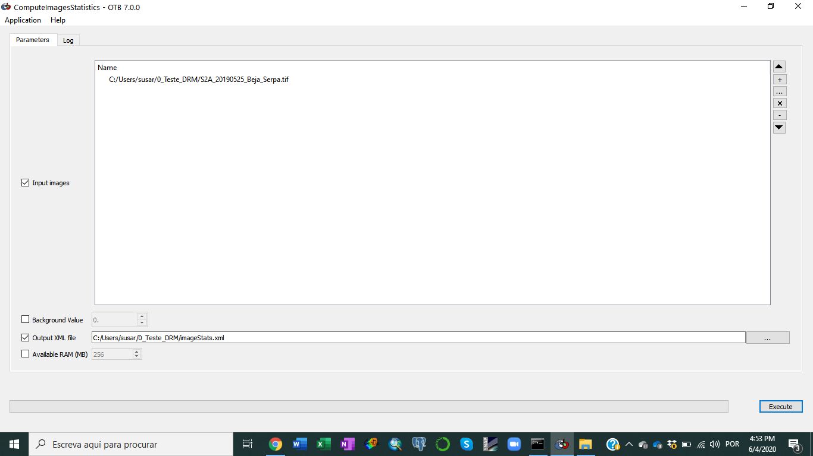
2020-06-04 13:59:40 (INFO) ComputeImagesStatistics: Default RAM limit for OTB is 256 MB

2020-06-04 13:59:40 (INFO) ComputeImagesStatistics: GDAL maximum cache size is 403 MB

2020-06-04 13:59:40 (INFO) ComputeImagesStatistics: OTB will use at most 4 threads

2020-06-04 13:59:49 (INFO) ComputeImagesStatistics: Execution took 9.427 sec

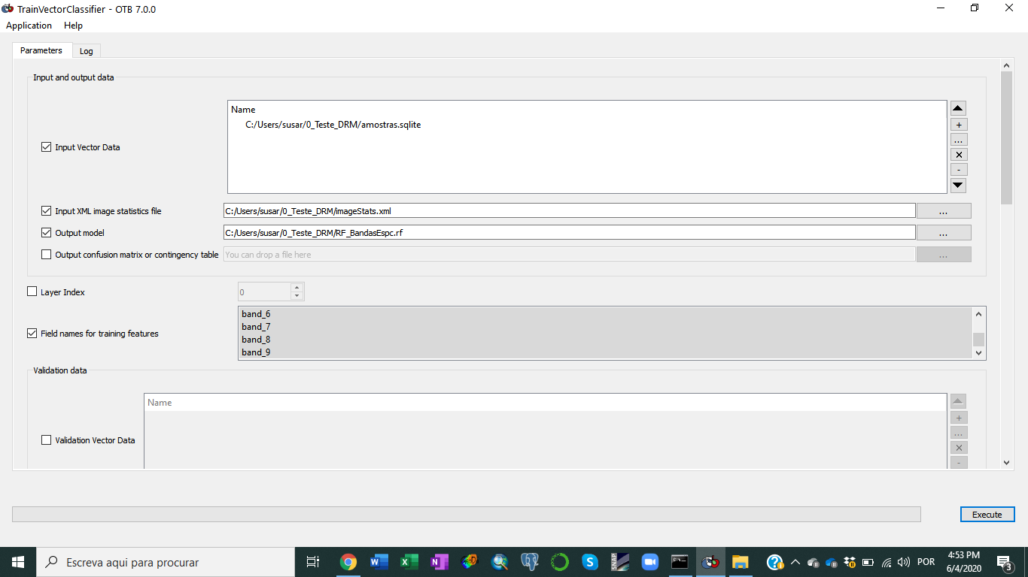
2020-06-04 14:02:17 (INFO) TrainVectorClassifier: Default RAM limit for OTB is 256 MB

2020-06-04 14:02:17 (INFO) TrainVectorClassifier: GDAL maximum cache size is 403 MB

2020-06-04 14:02:17 (INFO) TrainVectorClassifier: OTB will use at most 4 threads

2020-06-04 14:02:17 (INFO) TrainVectorClassifier: Reading vector file 1/1

2020-06-04 14:02:17 (WARNING) TrainVectorClassifier: The validation set is empty. The performance estimation is done using the input training set in this case.

2020-06-04 14:02:17 (INFO) TrainVectorClassifier: Computing model file : C:/Users/susar/0_Teste_DRM/RF_BandasEspc.rf

2020-06-04 14:02:25 (INFO) TrainVectorClassifier: Predicted list size : 58557

2020-06-04 14:02:25 (INFO) TrainVectorClassifier: ValidationLabeledListSample size : 58557

2020-06-04 14:02:25 (INFO) TrainVectorClassifier: Training performances:

2020-06-04 14:02:25 (INFO) TrainVectorClassifier: Confusion matrix (rows = reference labels, columns = produced labels):
[100] [200] [300] [301] [400] [401] [500] [600] [700] [800] [900]
[100] 13357 13 1 1 0 0 0 17 0 37 0
[200] 0 1229 85 18 0 77 198 0 381 0 166
[300] 0 0 9703 1 42 6 0 0 52 28 66
[301] 0 9 675 405 14 128 4 45 173 0 454
[400] 0 0 2125 0 3018 0 5 50 187 55 72
[401] 0 0 147 113 0 1246 0 0 946 0 1332
[500] 0 438 51 113 0 42 1394 5 458 0 232
[600] 0 0 19 35 0 0 0 1404 0 4 0
[700] 0 283 70 36 94 82 255 8 7615 0 290
[800] 4 0 294 0 26 0 0 57 0 2053 2
[900] 0 2 21 0 3 53 0 43 545 0 5845

2020-06-04 14:02:25 (INFO) TrainVectorClassifier: Precision of class [100] vs all: 0.999701

2020-06-04 14:02:25 (INFO) TrainVectorClassifier: Recall of class [100] vs all: 0.994861

2020-06-04 14:02:25 (INFO) TrainVectorClassifier: F-score of class [100] vs all: 0.997275

2020-06-04 14:02:25 (INFO) TrainVectorClassifier: Precision of class [200] vs all: 0.622594

2020-06-04 14:02:25 (INFO) TrainVectorClassifier: Recall of class [200] vs all: 0.570566

2020-06-04 14:02:25 (INFO) TrainVectorClassifier: F-score of class [200] vs all: 0.595446

2020-06-04 14:02:25 (INFO) TrainVectorClassifier: Precision of class [300] vs all: 0.735577

2020-06-04 14:02:25 (INFO) TrainVectorClassifier: Recall of class [300] vs all: 0.980299

2020-06-04 14:02:25 (INFO) TrainVectorClassifier: F-score of class [300] vs all: 0.840487

2020-06-04 14:02:25 (INFO) TrainVectorClassifier: Precision of class [301] vs all: 0.560942

2020-06-04 14:02:25 (INFO) TrainVectorClassifier: Recall of class [301] vs all: 0.212375

2020-06-04 14:02:25 (INFO) TrainVectorClassifier: F-score of class [301] vs all: 0.308102

2020-06-04 14:02:25 (INFO) TrainVectorClassifier: Precision of class [400] vs all: 0.94401

2020-06-04 14:02:25 (INFO) TrainVectorClassifier: Recall of class [400] vs all: 0.547533

2020-06-04 14:02:25 (INFO) TrainVectorClassifier: F-score of class [400] vs all: 0.693076

2020-06-04 14:02:25 (INFO) TrainVectorClassifier: Precision of class [401] vs all: 0.762546

2020-06-04 14:02:25 (INFO) TrainVectorClassifier: Recall of class [401] vs all: 0.329281

2020-06-04 14:02:25 (INFO) TrainVectorClassifier: F-score of class [401] vs all: 0.459948

2020-06-04 14:02:25 (INFO) TrainVectorClassifier: Precision of class [500] vs all: 0.751078

2020-06-04 14:02:25 (INFO) TrainVectorClassifier: Recall of class [500] vs all: 0.510062

2020-06-04 14:02:25 (INFO) TrainVectorClassifier: F-score of class [500] vs all: 0.60754

2020-06-04 14:02:25 (INFO) TrainVectorClassifier: Precision of class [600] vs all: 0.861878

2020-06-04 14:02:25 (INFO) TrainVectorClassifier: Recall of class [600] vs all: 0.960328

2020-06-04 14:02:25 (INFO) TrainVectorClassifier: F-score of class [600] vs all: 0.908444

2020-06-04 14:02:25 (INFO) TrainVectorClassifier: Precision of class [700] vs all: 0.735252

2020-06-04 14:02:25 (INFO) TrainVectorClassifier: Recall of class [700] vs all: 0.87198

2020-06-04 14:02:25 (INFO) TrainVectorClassifier: F-score of class [700] vs all: 0.7978

2020-06-04 14:02:25 (INFO) TrainVectorClassifier: Precision of class [800] vs all: 0.943041

2020-06-04 14:02:25 (INFO) TrainVectorClassifier: Recall of class [800] vs all: 0.842775

2020-06-04 14:02:25 (INFO) TrainVectorClassifier: F-score of class [800] vs all: 0.890093

2020-06-04 14:02:25 (INFO) TrainVectorClassifier: Precision of class [900] vs all: 0.69098

2020-06-04 14:02:25 (INFO) TrainVectorClassifier: Recall of class [900] vs all: 0.897574

2020-06-04 14:02:25 (INFO) TrainVectorClassifier: F-score of class [900] vs all: 0.780843

2020-06-04 14:02:25 (INFO) TrainVectorClassifier: Global performance, Kappa index: 0.774502

2020-06-04 14:02:25 (INFO) TrainVectorClassifier: Execution took 8.329 sec

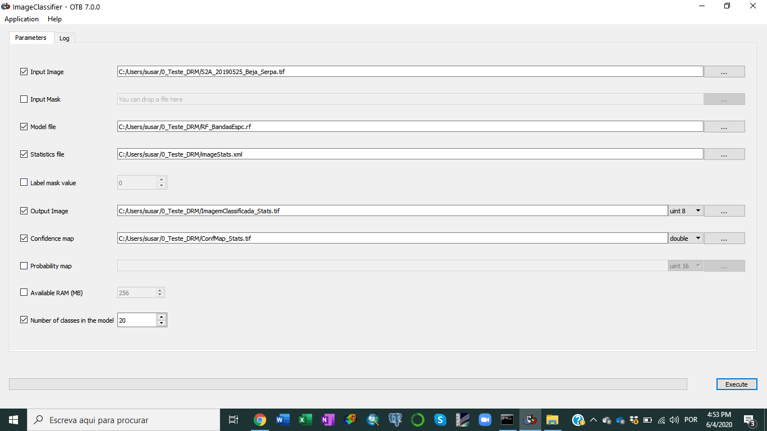
2020-06-04 14:04:57 (INFO) ImageClassifier: Default RAM limit for OTB is 256 MB

2020-06-04 14:04:57 (INFO) ImageClassifier: GDAL maximum cache size is 403 MB

2020-06-04 14:04:57 (INFO) ImageClassifier: OTB will use at most 4 threads

2020-06-04 14:04:57 (INFO) ImageClassifier: Loading model

2020-06-04 14:04:57 (INFO) ImageClassifier: Model loaded

2020-06-04 14:04:57 (INFO) ImageClassifier: Input image normalization activated.

2020-06-04 14:04:57 (FATAL) ImageClassifier: itk::ERROR: StatisticsXMLFileReader(00000215C07E19E0): No entry corresponding to the token selected (mean) in the XML file

2020-06-04 14:05:53 (INFO) ImageClassifier: Loading model

2020-06-04 14:05:53 (INFO) ImageClassifier: Model loaded

2020-06-04 14:05:53 (INFO) ImageClassifier: Input image normalization activated.

2020-06-04 14:05:53 (INFO) ImageClassifier: mean used: [0.0677021, 0.100234, 0.135987, 0.173924, 0.223805, 0.248218, 0.26497, 0.276882, 0.30843, 0.212408]

2020-06-04 14:05:53 (INFO) ImageClassifier: standard deviation used: [0.0227584, 0.0283242, 0.0444704, 0.043343, 0.04578, 0.0509314, 0.0546291, 0.054475, 0.0701158, 0.0589014]

2020-06-04 14:07:32 (INFO) ImageClassifier: Execution took 98.059 sec

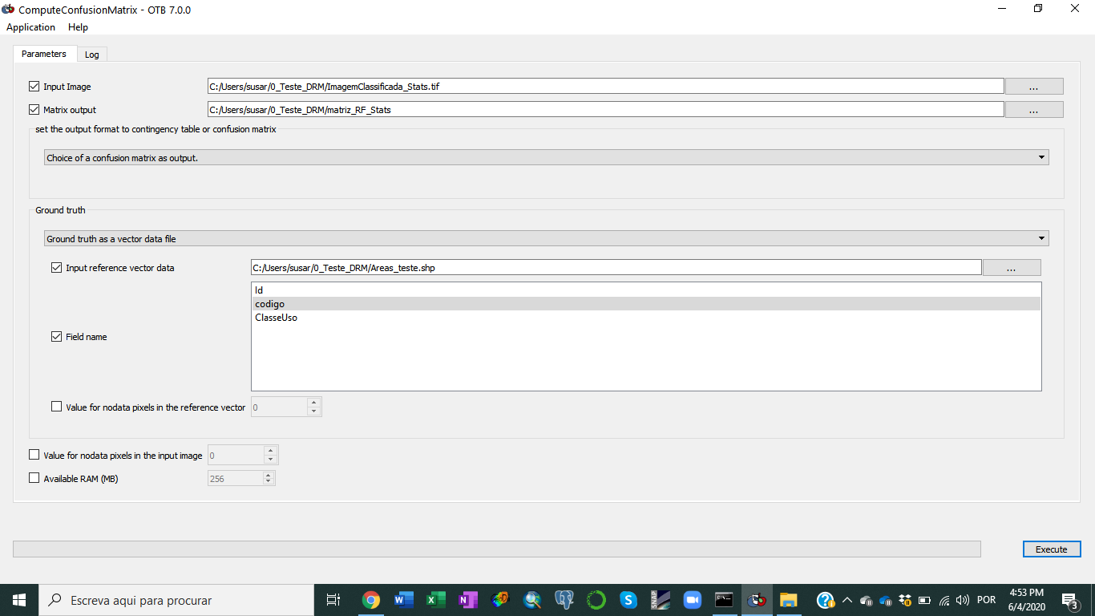
2020-06-04 14:12:42 (INFO) ComputeConfusionMatrix: Default RAM limit for OTB is 256 MB

2020-06-04 14:12:42 (INFO) ComputeConfusionMatrix: GDAL maximum cache size is 403 MB

2020-06-04 14:12:42 (INFO) ComputeConfusionMatrix: OTB will use at most 4 threads

2020-06-04 14:12:42 (INFO) ComputeConfusionMatrix: Number of stream divisions : 3

2020-06-04 14:12:43 (INFO) ComputeConfusionMatrix: mapOfClassesRef[100] = 0

2020-06-04 14:12:43 (INFO) ComputeConfusionMatrix: mapOfClassesRef[200] = 1

2020-06-04 14:12:43 (INFO) ComputeConfusionMatrix: mapOfClassesRef[300] = 2

2020-06-04 14:12:43 (INFO) ComputeConfusionMatrix: mapOfClassesRef[301] = 3

2020-06-04 14:12:43 (INFO) ComputeConfusionMatrix: mapOfClassesRef[400] = 4

2020-06-04 14:12:43 (INFO) ComputeConfusionMatrix: mapOfClassesRef[401] = 5

2020-06-04 14:12:43 (INFO) ComputeConfusionMatrix: mapOfClassesRef[500] = 6

2020-06-04 14:12:43 (INFO) ComputeConfusionMatrix: mapOfClassesRef[600] = 7

2020-06-04 14:12:43 (INFO) ComputeConfusionMatrix: mapOfClassesRef[700] = 8

2020-06-04 14:12:43 (INFO) ComputeConfusionMatrix: mapOfClassesRef[800] = 9

2020-06-04 14:12:43 (INFO) ComputeConfusionMatrix: mapOfClassesRef[900] = 10

2020-06-04 14:12:43 (INFO) ComputeConfusionMatrix: mapOfClassesProd[100] = 0

2020-06-04 14:12:43 (INFO) ComputeConfusionMatrix: mapOfClassesProd[200] = 1

2020-06-04 14:12:43 (INFO) ComputeConfusionMatrix: mapOfClassesProd[255] = 2

2020-06-04 14:12:43 (INFO) ComputeConfusionMatrix: Reference class labels ordered according to the rows of the output confusion matrix: #Reference labels (rows):100,200,300,301,400,401,500,600,700,800,900

2020-06-04 14:12:43 (INFO) ComputeConfusionMatrix: Produced class labels ordered according to the columns of the output confusion matrix: #Produced labels (columns):100,200,255

2020-06-04 14:12:43 (INFO) ComputeConfusionMatrix: Confusion matrix (rows = reference labels, columns = produced labels):
[100] [200] [300] [301] [400] [401] [500] [600] [700] [800] [900]
[100] 4436 0 0 0 0 0 0 0 0 0 0
[200] 0 449 0 0 0 0 0 0 0 0 0
[300] 0 0 0 0 0 0 0 0 0 0 0
[301] 0 4 0 0 0 0 0 0 0 0 0
[400] 0 56 0 0 0 0 0 0 0 0 0
[401] 0 12 0 0 0 0 0 0 0 0 0
[500] 7 288 0 0 0 0 0 0 0 0 0
[600] 0 0 0 0 0 0 0 0 0 0 0
[700] 0 486 0 0 0 0 0 0 0 0 0
[800] 0 0 0 0 0 0 0 0 0 0 0
[900] 0 6 0 0 0 0 0 0 0 0 0

2020-06-04 14:12:43 (INFO) ComputeConfusionMatrix: Precision of class [100] vs all: 0.998424

2020-06-04 14:12:43 (INFO) ComputeConfusionMatrix: Recall of class [100] vs all: 1

2020-06-04 14:12:43 (INFO) ComputeConfusionMatrix: F-score of class [100] vs all: 0.999212

2020-06-04 14:12:43 (INFO) ComputeConfusionMatrix: Precision of class [200] vs all: 0.345119

2020-06-04 14:12:43 (INFO) ComputeConfusionMatrix: Recall of class [200] vs all: 1

2020-06-04 14:12:43 (INFO) ComputeConfusionMatrix: F-score of class [200] vs all: 0.513143

2020-06-04 14:12:43 (INFO) ComputeConfusionMatrix: Precision of class [300] vs all: 0

2020-06-04 14:12:43 (INFO) ComputeConfusionMatrix: Recall of class [300] vs all: 0

2020-06-04 14:12:43 (INFO) ComputeConfusionMatrix: F-score of class [300] vs all: 0

2020-06-04 14:12:43 (INFO) ComputeConfusionMatrix: Precision of class [301] vs all: 0

2020-06-04 14:12:43 (INFO) ComputeConfusionMatrix: Recall of class [301] vs all: 0

2020-06-04 14:12:43 (INFO) ComputeConfusionMatrix: F-score of class [301] vs all: 0

2020-06-04 14:12:43 (INFO) ComputeConfusionMatrix: Precision of class [400] vs all: 0

2020-06-04 14:12:43 (INFO) ComputeConfusionMatrix: Recall of class [400] vs all: 0

2020-06-04 14:12:43 (INFO) ComputeConfusionMatrix: F-score of class [400] vs all: 0

2020-06-04 14:12:43 (INFO) ComputeConfusionMatrix: Precision of class [401] vs all: 0

2020-06-04 14:12:43 (INFO) ComputeConfusionMatrix: Recall of class [401] vs all: 0

2020-06-04 14:12:43 (INFO) ComputeConfusionMatrix: F-score of class [401] vs all: 0

2020-06-04 14:12:43 (INFO) ComputeConfusionMatrix: Precision of class [500] vs all: 0

2020-06-04 14:12:43 (INFO) ComputeConfusionMatrix: Recall of class [500] vs all: 0

2020-06-04 14:12:43 (INFO) ComputeConfusionMatrix: F-score of class [500] vs all: 0

2020-06-04 14:12:43 (INFO) ComputeConfusionMatrix: Precision of class [600] vs all: 0

2020-06-04 14:12:43 (INFO) ComputeConfusionMatrix: Recall of class [600] vs all: 0

2020-06-04 14:12:43 (INFO) ComputeConfusionMatrix: F-score of class [600] vs all: 0

2020-06-04 14:12:43 (INFO) ComputeConfusionMatrix: Precision of class [700] vs all: 0

2020-06-04 14:12:43 (INFO) ComputeConfusionMatrix: Recall of class [700] vs all: 0

2020-06-04 14:12:43 (INFO) ComputeConfusionMatrix: F-score of class [700] vs all: 0

2020-06-04 14:12:43 (INFO) ComputeConfusionMatrix: Precision of class [800] vs all: 0

2020-06-04 14:12:43 (INFO) ComputeConfusionMatrix: Recall of class [800] vs all: 0

2020-06-04 14:12:43 (INFO) ComputeConfusionMatrix: F-score of class [800] vs all: 0

2020-06-04 14:12:43 (INFO) ComputeConfusionMatrix: Precision of class [900] vs all: 0

2020-06-04 14:12:43 (INFO) ComputeConfusionMatrix: Recall of class [900] vs all: 0

2020-06-04 14:12:43 (INFO) ComputeConfusionMatrix: F-score of class [900] vs all: 0

2020-06-04 14:12:43 (INFO) ComputeConfusionMatrix: Precision of the different classes: [0.998424, 0.345119, 0, 0, 0, 0, 0, 0, 0, 0, 0]

2020-06-04 14:12:43 (INFO) ComputeConfusionMatrix: Recall of the different classes: [1, 1, 0, 0, 0, 0, 0, 0, 0, 0, 0]

2020-06-04 14:12:43 (INFO) ComputeConfusionMatrix: F-score of the different classes: [0.999212, 0.513143, 0, 0, 0, 0, 0, 0, 0, 0, 0]

2020-06-04 14:12:43 (INFO) ComputeConfusionMatrix: Kappa index: 0.611496

2020-06-04 14:12:43 (INFO) ComputeConfusionMatrix: Overall accuracy index: 0.850453

2020-06-04 14:12:43 (INFO) ComputeConfusionMatrix: Execution took 0.354 sec

