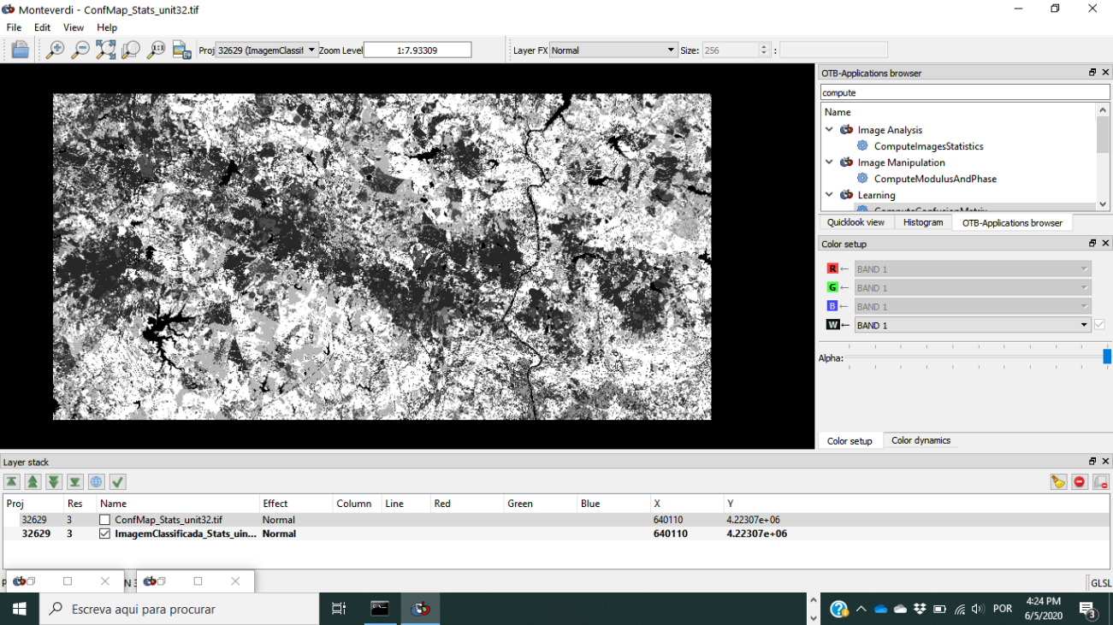

2020-06-05 16:15:15 (INFO) ComputeConfusionMatrix: Default RAM limit for OTB is 256 MB

2020-06-05 16:15:15 (INFO) ComputeConfusionMatrix: GDAL maximum cache size is 403 MB

2020-06-05 16:15:15 (INFO) ComputeConfusionMatrix: OTB will use at most 4 threads

2020-06-05 16:15:15 (INFO) ComputeConfusionMatrix: Number of stream divisions : 3

2020-06-05 16:15:15 (INFO) ComputeConfusionMatrix: mapOfClassesRef[100] = 0

2020-06-05 16:15:15 (INFO) ComputeConfusionMatrix: mapOfClassesRef[200] = 1

2020-06-05 16:15:15 (INFO) ComputeConfusionMatrix: mapOfClassesRef[300] = 2

2020-06-05 16:15:15 (INFO) ComputeConfusionMatrix: mapOfClassesRef[301] = 3

2020-06-05 16:15:15 (INFO) ComputeConfusionMatrix: mapOfClassesRef[400] = 4

2020-06-05 16:15:15 (INFO) ComputeConfusionMatrix: mapOfClassesRef[401] = 5

2020-06-05 16:15:15 (INFO) ComputeConfusionMatrix: mapOfClassesRef[500] = 6

2020-06-05 16:15:15 (INFO) ComputeConfusionMatrix: mapOfClassesRef[600] = 7

2020-06-05 16:15:15 (INFO) ComputeConfusionMatrix: mapOfClassesRef[700] = 8

2020-06-05 16:15:15 (INFO) ComputeConfusionMatrix: mapOfClassesRef[800] = 9

2020-06-05 16:15:15 (INFO) ComputeConfusionMatrix: mapOfClassesRef[900] = 10

2020-06-05 16:15:15 (INFO) ComputeConfusionMatrix: mapOfClassesProd[100] = 0

2020-06-05 16:15:15 (INFO) ComputeConfusionMatrix: mapOfClassesProd[200] = 1

2020-06-05 16:15:15 (INFO) ComputeConfusionMatrix: mapOfClassesProd[300] = 2

2020-06-05 16:15:15 (INFO) ComputeConfusionMatrix: mapOfClassesProd[400] = 3

2020-06-05 16:15:15 (INFO) ComputeConfusionMatrix: mapOfClassesProd[401] = 4

2020-06-05 16:15:15 (INFO) ComputeConfusionMatrix: mapOfClassesProd[500] = 5

2020-06-05 16:15:15 (INFO) ComputeConfusionMatrix: mapOfClassesProd[600] = 6

2020-06-05 16:15:15 (INFO) ComputeConfusionMatrix: mapOfClassesProd[700] = 7

2020-06-05 16:15:15 (INFO) ComputeConfusionMatrix: mapOfClassesProd[800] = 8

2020-06-05 16:15:15 (INFO) ComputeConfusionMatrix: mapOfClassesProd[900] = 9

2020-06-05 16:15:15 (INFO) ComputeConfusionMatrix: Reference class labels ordered according to the rows of the output confusion matrix: #Reference labels (rows):100,200,300,301,400,401,500,600,700,800,900

2020-06-05 16:15:15 (INFO) ComputeConfusionMatrix: Produced class labels ordered according to the columns of the output confusion matrix: #Produced labels (columns):100,200,300,400,401,500,600,700,800,900

2020-06-05 16:15:15 (INFO) ComputeConfusionMatrix: Confusion matrix (rows = reference labels, columns = produced labels):
[100] [200] [300] [301] [400] [401] [500] [600] [700] [800] [900]
[100] 4438 2 3 0 0 0 0 17 0 1 0
[200] 0 463 108 0 1 19 55 0 157 0 23
[300] 0 2 5456 0 0 0 0 0 0 1 18
[301] 0 4 467 0 34 48 0 15 26 0 223
[400] 0 4 696 0 1247 0 0 0 126 414 272
[401] 0 13 4 0 0 1058 0 0 354 0 499
[500] 7 273 142 0 0 57 210 0 219 0 72
[600] 0 0 21 0 0 0 0 507 0 4 5
[700] 0 505 127 0 172 69 351 2 3688 2 223
[800] 0 0 130 0 19 0 0 65 0 791 0
[900] 0 2 61 0 0 42 0 30 301 0 2233

2020-06-05 16:15:15 (INFO) ComputeConfusionMatrix: Precision of class [100] vs all: 0.998425

2020-06-05 16:15:15 (INFO) ComputeConfusionMatrix: Recall of class [100] vs all: 0.994844

2020-06-05 16:15:15 (INFO) ComputeConfusionMatrix: F-score of class [100] vs all: 0.996631

2020-06-05 16:15:15 (INFO) ComputeConfusionMatrix: Precision of class [200] vs all: 0.365142

2020-06-05 16:15:15 (INFO) ComputeConfusionMatrix: Recall of class [200] vs all: 0.560533

2020-06-05 16:15:15 (INFO) ComputeConfusionMatrix: F-score of class [200] vs all: 0.442216

2020-06-05 16:15:15 (INFO) ComputeConfusionMatrix: Precision of class [300] vs all: 0.756202

2020-06-05 16:15:15 (INFO) ComputeConfusionMatrix: Recall of class [300] vs all: 0.996166

2020-06-05 16:15:15 (INFO) ComputeConfusionMatrix: F-score of class [300] vs all: 0.859754

2020-06-05 16:15:15 (INFO) ComputeConfusionMatrix: Precision of class [301] vs all: 0

2020-06-05 16:15:15 (INFO) ComputeConfusionMatrix: Recall of class [301] vs all: 0

2020-06-05 16:15:15 (INFO) ComputeConfusionMatrix: F-score of class [301] vs all: 0

2020-06-05 16:15:15 (INFO) ComputeConfusionMatrix: Precision of class [400] vs all: 0.846572

2020-06-05 16:15:15 (INFO) ComputeConfusionMatrix: Recall of class [400] vs all: 0.451975

2020-06-05 16:15:15 (INFO) ComputeConfusionMatrix: F-score of class [400] vs all: 0.589319

2020-06-05 16:15:15 (INFO) ComputeConfusionMatrix: Precision of class [401] vs all: 0.818252

2020-06-05 16:15:15 (INFO) ComputeConfusionMatrix: Recall of class [401] vs all: 0.548755

2020-06-05 16:15:15 (INFO) ComputeConfusionMatrix: F-score of class [401] vs all: 0.656939

2020-06-05 16:15:15 (INFO) ComputeConfusionMatrix: Precision of class [500] vs all: 0.340909

2020-06-05 16:15:15 (INFO) ComputeConfusionMatrix: Recall of class [500] vs all: 0.214286

2020-06-05 16:15:15 (INFO) ComputeConfusionMatrix: F-score of class [500] vs all: 0.263158

2020-06-05 16:15:15 (INFO) ComputeConfusionMatrix: Precision of class [600] vs all: 0.79717

2020-06-05 16:15:15 (INFO) ComputeConfusionMatrix: Recall of class [600] vs all: 0.944134

2020-06-05 16:15:15 (INFO) ComputeConfusionMatrix: F-score of class [600] vs all: 0.86445

2020-06-05 16:15:15 (INFO) ComputeConfusionMatrix: Precision of class [700] vs all: 0.757134

2020-06-05 16:15:15 (INFO) ComputeConfusionMatrix: Recall of class [700] vs all: 0.717649

2020-06-05 16:15:15 (INFO) ComputeConfusionMatrix: F-score of class [700] vs all: 0.736863

2020-06-05 16:15:15 (INFO) ComputeConfusionMatrix: Precision of class [800] vs all: 0.652102

2020-06-05 16:15:15 (INFO) ComputeConfusionMatrix: Recall of class [800] vs all: 0.787065

2020-06-05 16:15:15 (INFO) ComputeConfusionMatrix: F-score of class [800] vs all: 0.713255

2020-06-05 16:15:15 (INFO) ComputeConfusionMatrix: Precision of class [900] vs all: 0.625841

2020-06-05 16:15:15 (INFO) ComputeConfusionMatrix: Recall of class [900] vs all: 0.836643

2020-06-05 16:15:15 (INFO) ComputeConfusionMatrix: F-score of class [900] vs all: 0.716049

2020-06-05 16:15:15 (INFO) ComputeConfusionMatrix: Precision of the different classes: [0.998425, 0.365142, 0.756202, 0, 0.846572, 0.818252, 0.340909, 0.79717, 0.757134, 0.652102, 0.625841]

2020-06-05 16:15:15 (INFO) ComputeConfusionMatrix: Recall of the different classes: [0.994844, 0.560533, 0.996166, 0, 0.451975, 0.548755, 0.214286, 0.944134, 0.717649, 0.787065, 0.836643]

2020-06-05 16:15:15 (INFO) ComputeConfusionMatrix: F-score of the different classes: [0.996631, 0.442216, 0.859754, 0, 0.589319, 0.656939, 0.263158, 0.86445, 0.736863, 0.713255, 0.716049]

2020-06-05 16:15:15 (INFO) ComputeConfusionMatrix: Kappa index: 0.713353

2020-06-05 16:15:15 (INFO) ComputeConfusionMatrix: Overall accuracy index: 0.755358

2020-06-05 16:15:15 (INFO) ComputeConfusionMatrix: Execution took 0.557 sec

