CLASSIFICATION
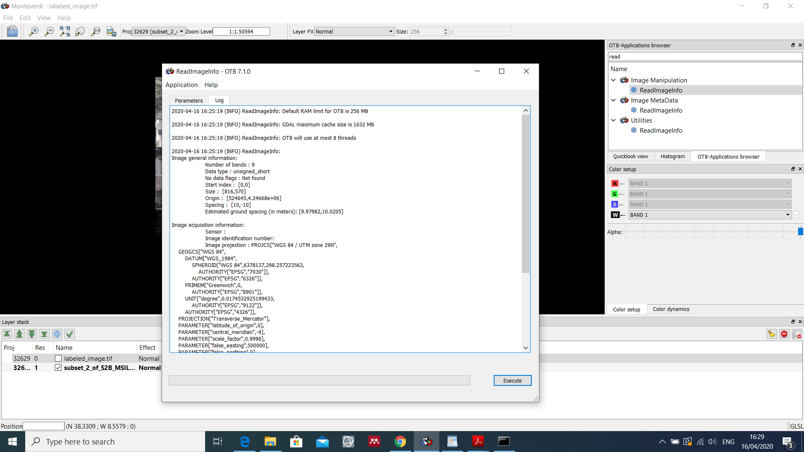
Step 1. PolygonClassStatistics
In this step I am using the attribute “code” and considering only 4 classes (10 – crop, baresoil – 20, dryvegetation – 30 and forest – 40)
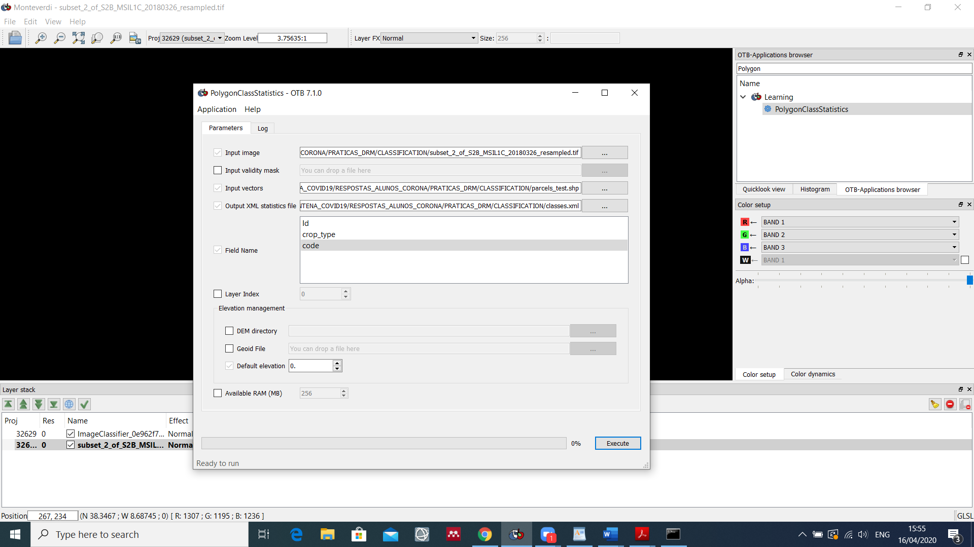
Step 2. SampleSelection
In this step I am using Total strategy (considering 32 samples - ~70% - of a total of 46 samples) and Random.
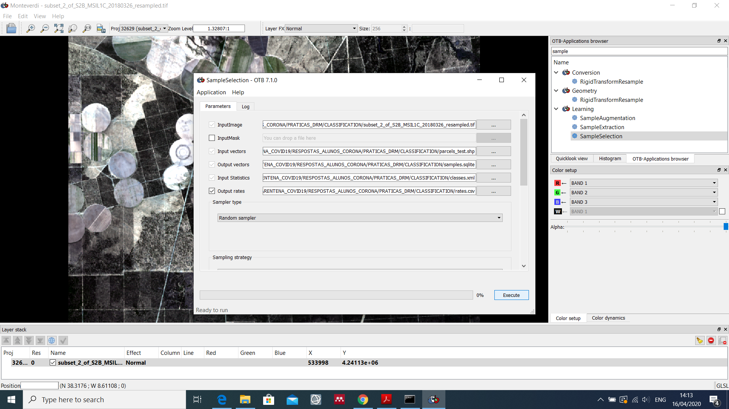

Step 3. SampleExtraction
I am not using output samples, so the *.sqlite file is updated!
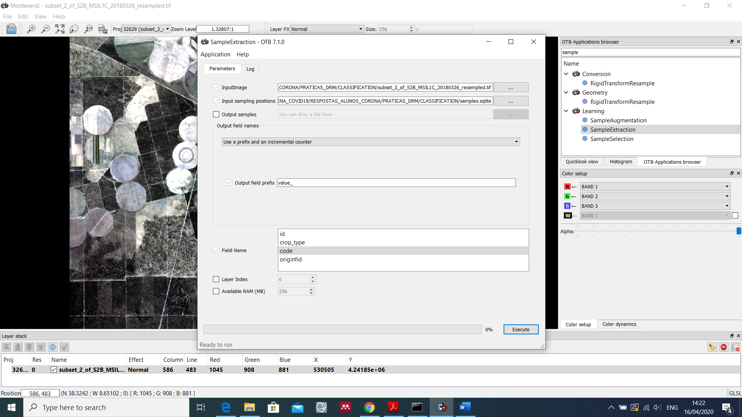

Step 4. ComputeImagesStatistics
I am not quite sure if this step is really necessary!
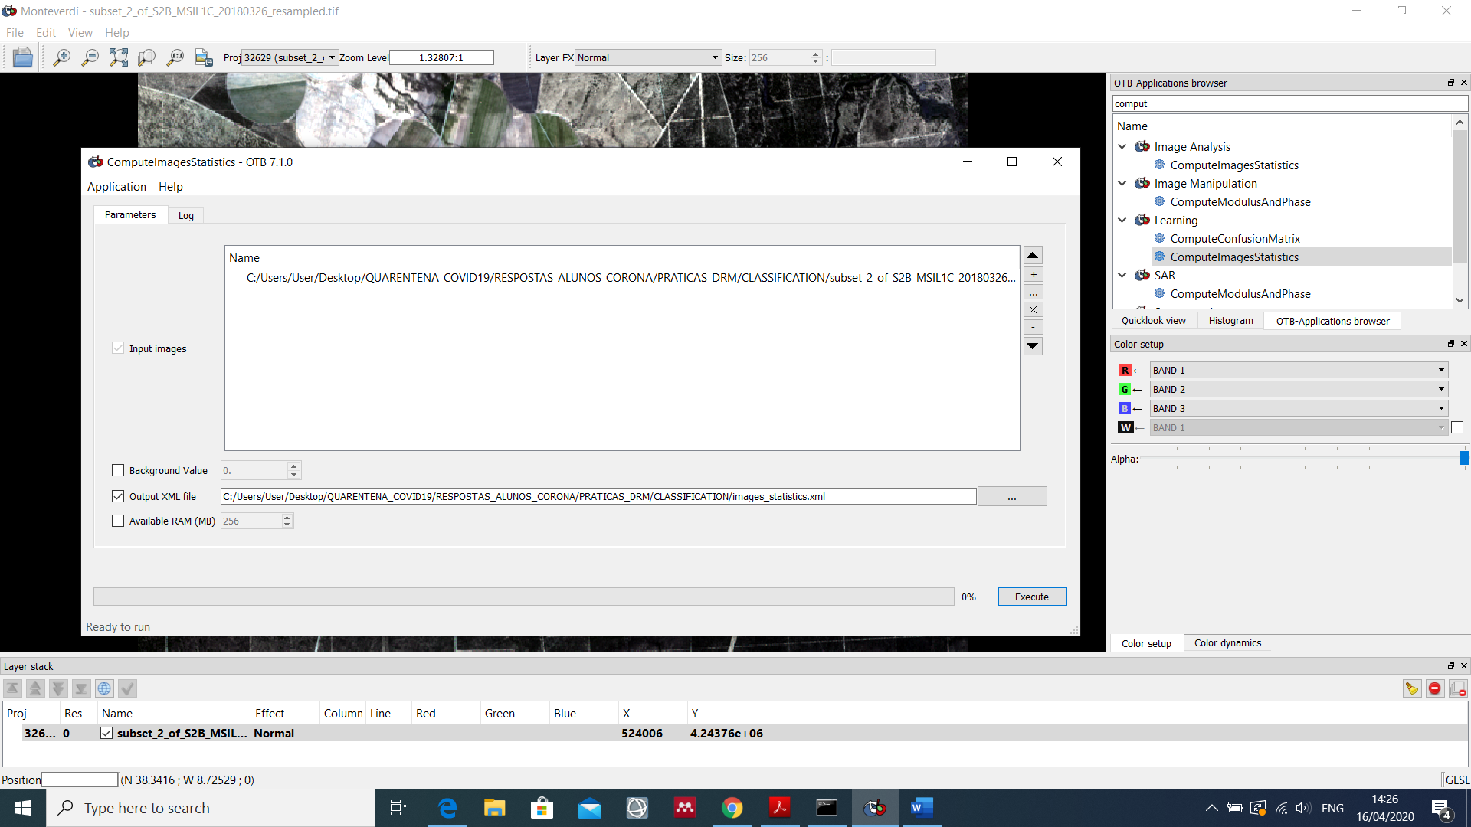

Step 5. TrainVectorClassifier
I am using RF with the default values for the parameters.
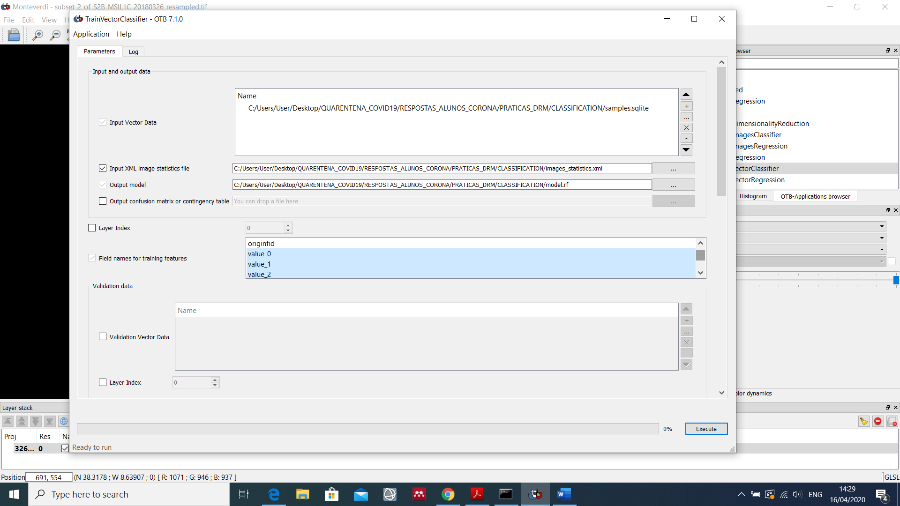
…
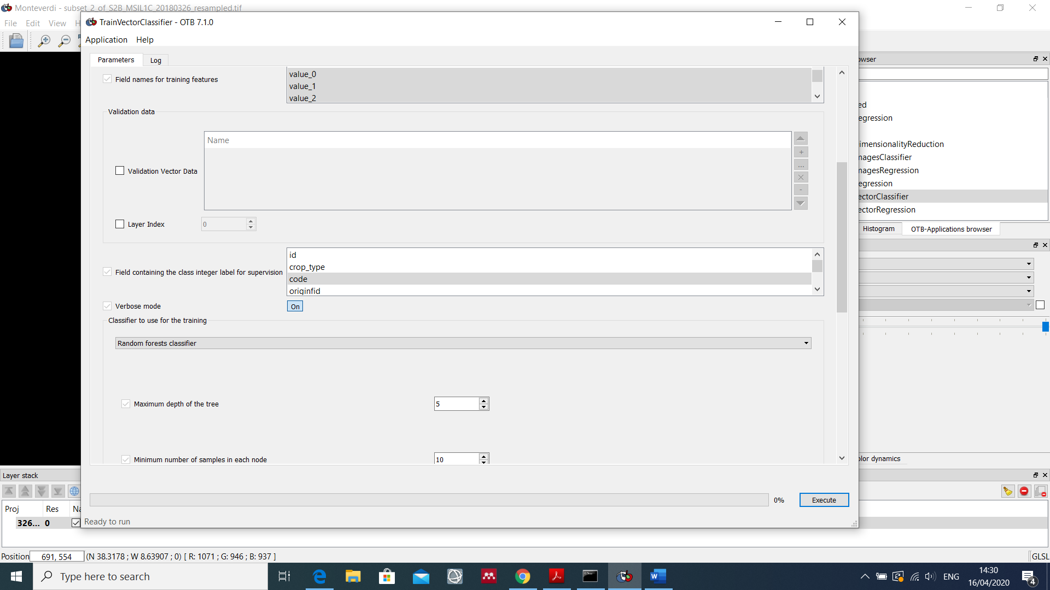

Step 6. ImageClassifier
I get a “black Image” with all pixels with value 20 corresponding to class “baresoil”!
After, I used ColorMapping, and I still get a “black image” although RGB is 178, 153, 63 (light yellow), corresponding to the color I have defined in a lut_mapping_file.
